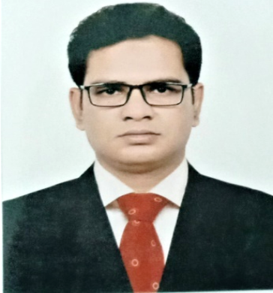

**RAFIQUEL ISLAM**

**Address:** House 511, West, Bandutia, Manikganj-1800

**Phone:** +8801713509576

**E-mail:** [rafiquel31islam@gmail.com](mailto:rafiquel31islam@gmail.com)

|  |  |
| --- | --- |
| **OBJECTIVE** | A resourceful individual with a proven track record in implementing successful marketing strategies, boosting organic traffic and improving search rankings seeks a position of Marketing Manager at an organization to maximize brand awareness and revenue through integrated marketing communication. |

|  |  |
| --- | --- |
| **WORK EXPERIENCE** | **Company Name: Nitol Motors Ltd.**  **Designation: Asst. Manager**  **Responsible Area: Area Sales Manager (ASM)**  **From:** 27 August 2012 – Present  **Responsibilities:**   * Establish operation strategy in a team for improving sales * Prepare data and information for making regular report data analysis * Distributing monthly sales target received from PM among the executives * Identify new business opportunities in various routes to maximize market coverage * Maintain liaison with local influential persons, spoke person, motivators and govt. authority * Supervise auto fair, Demo and other promotional activities   **Company Name: Dhaka Tabaco Industries Ltd.**  **Designation: Territory Officer**  **From:** 25 December 2010 – 31 July 2012  **Responsibilities:**   * Supervise the sales team and execute daily sales activities to ensure sales target achievement and maintain trade relations with business partners * Driving between different branches * Ensure each sales representative is equipped and driven to fulfill clients' present and future needs through consultative engagement * Implement corporate planning & policies in the market in line with sales forecast achievement * Develop territory, market penetration and sales execution strategies to consistently attain and exceed goals * Influencing consumer buying habits * Enhancing the distribution and availability of products in retail outlets * Create a strategy to grow the territory by building long term customer relationships * Attending all relevant trade shows and exhibitions * Recruiting, Train, Motivate and Coach a team of full time sales representatives * Maintaining and updating territory records of all customers * Look after depot operations of assigned territory   **Company Name: The ACME Laboratories Ltd.**  **Designation: Medical Representative**  **From:** 22 May 2009– 31 July 2010  **Responsibilities:**   * Visit doctors and healthcare professionals to promote company products and generate prescription. * Visit pharmacies for collecting order to achieve sales target assigned by the company. |

|  |  |
| --- | --- |
| **EDUCATION** | **Masters of Professional Marketing** ,University of Dhaka- 2020  **Masters of Business Studies,** National University-2007  **Bachelor of commerce,** National University-2006  **Higher secondary,** Dhaka Board -2002 |

|  |  |
| --- | --- |
| **KEY SKILLS** | Microsoft Office package: Microsoft Word, Excel, Access  Team Leadership Personal Traits  Business Competency  Functional Exposure |

|  |  |
| --- | --- |
| **Achievement** | Three times best achiever of the region, Nitol Motors Ltd. |

**PERSONAL**

**INFORMATION** Name : Rafiquel Islam

Father’s Name : Abul Hossain

Mother’s Name : Rehena Khandoker

Date of Birth : 15 February 1984

Gender : Male

Material Status : Married

Nationality : Bangladeshi by birth

Present Address : Nitol Motors Ltd,IIUC tower, Agrabad, P.O –Bandar, P.S - Double Mooring, Dist- Chattogram

Permeant Address : 511 West Bandutia, P.O- Manikganj, P.S & District: Manikganj

Current City : Chattogram

Home District : Manikganj

Present Salary : BDT 59,305

|  |  |  |
| --- | --- | --- |
| **References** | **Ahmed Sawkat Hossen**  CBO of SCV Cargo  Nitol Motors Ltd  71, Mohakhali, C/A Dhaka-1212  Cell: 01715673724 | **Dr. Haripoda Bhattacharjee**  Professor & Director of MPM  Faculty of Business Studies  University of Dhaka  Cell: 01742362243 |

**DECELERATION:** I do, hereby declare that the above statements are correct and complete to the best of my knowledge.

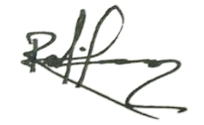

…………………………….

**RAFIQUEL ISLAM**